Dominic Baker

Prof. Lemma  
NWIT-291  
Lab 5 - BurpSuite - Intercept Requests  
  
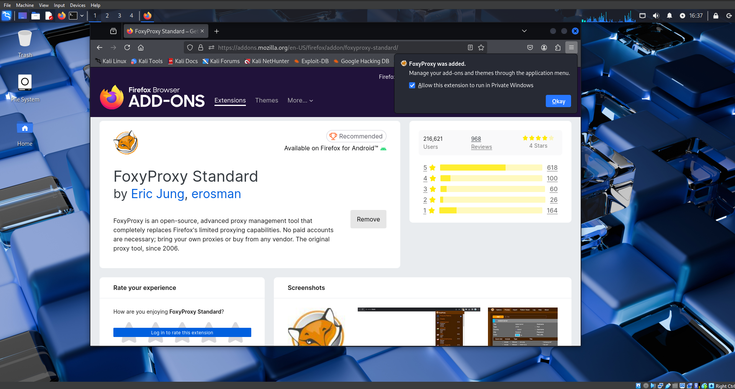  
*Fig. 1 - FoxyProxy successfully added as a Firefox extension.*

*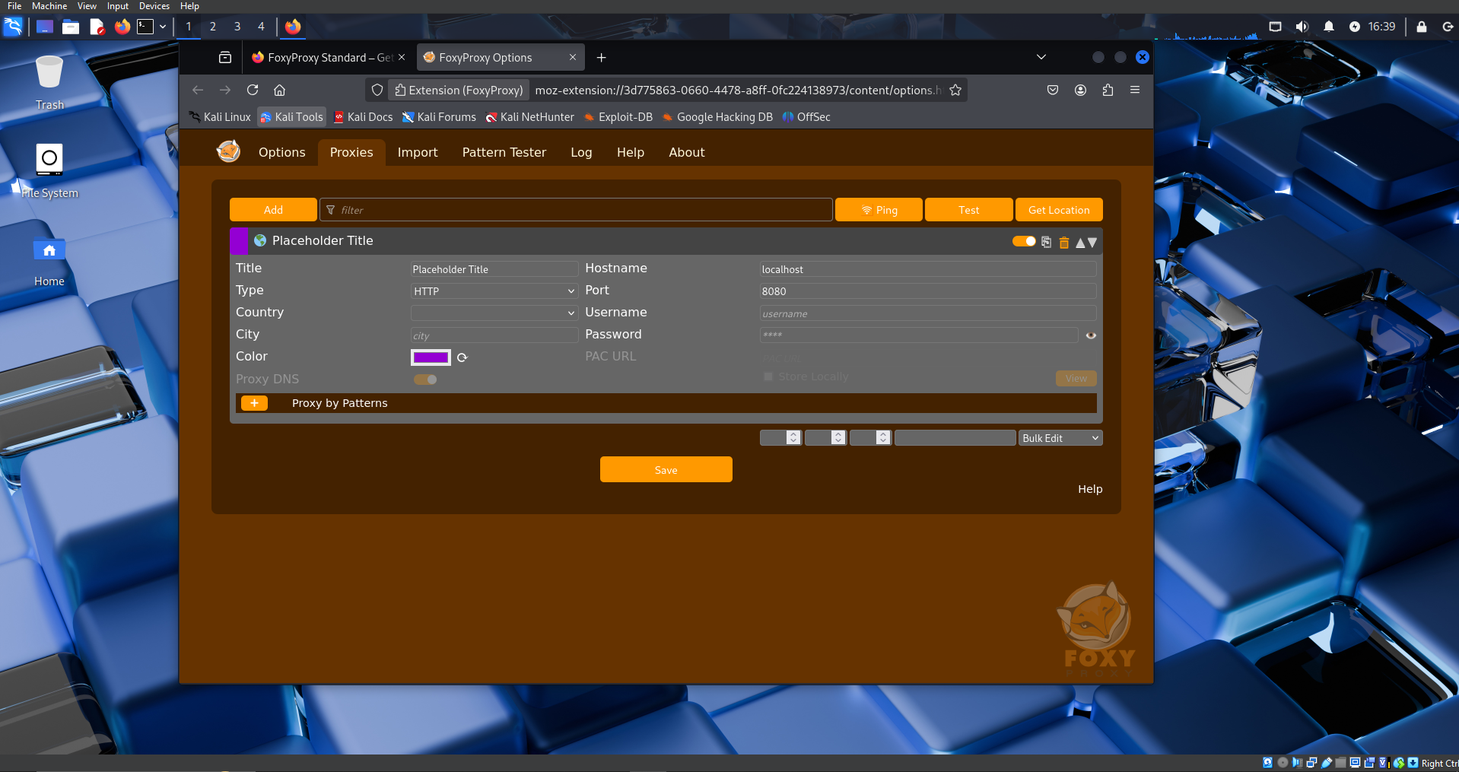  
Fig. 2 - Saved proxy in FoxyProxy using the parameters from the lab.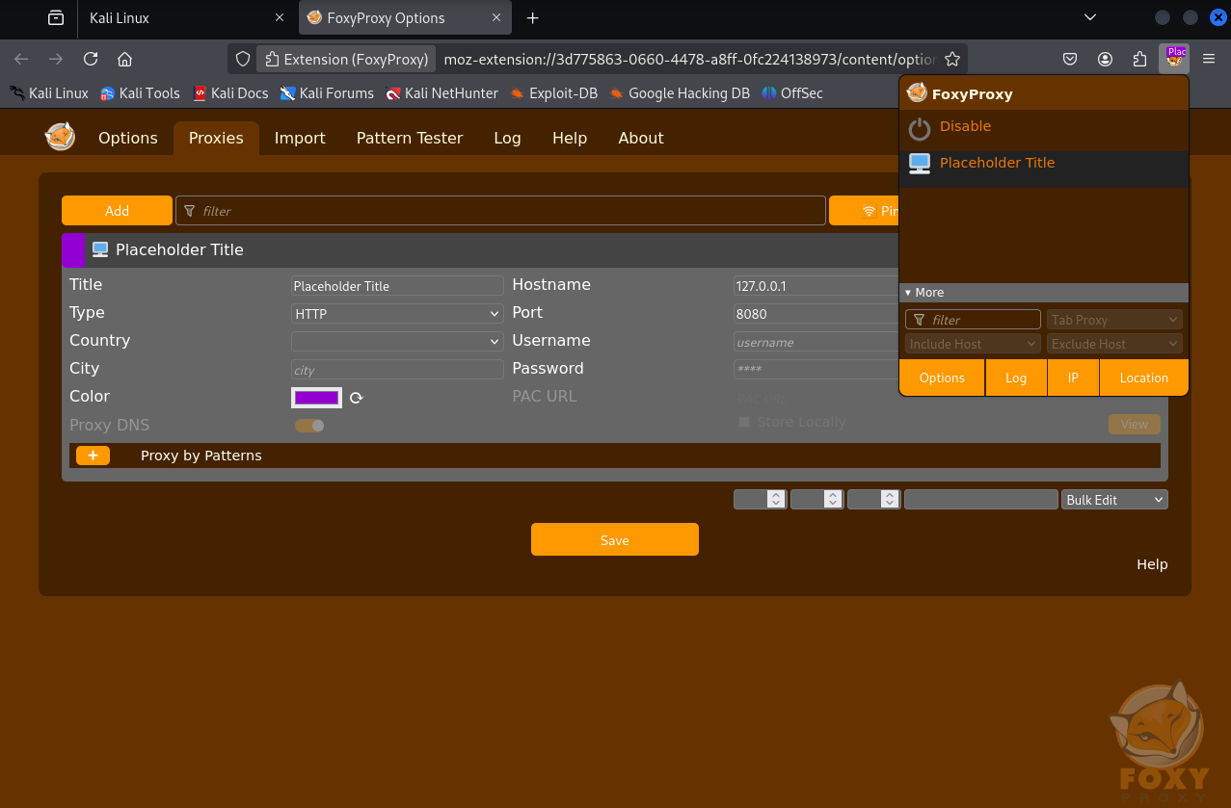Fig. 3 - My created proxy enabled on FoxyProxy.  
  
  
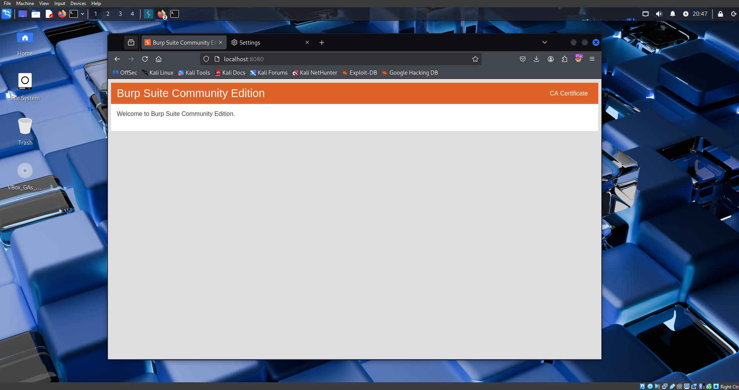  
Fig. 4 - The Certificate successfully downloaded from BurpSuite.  
  
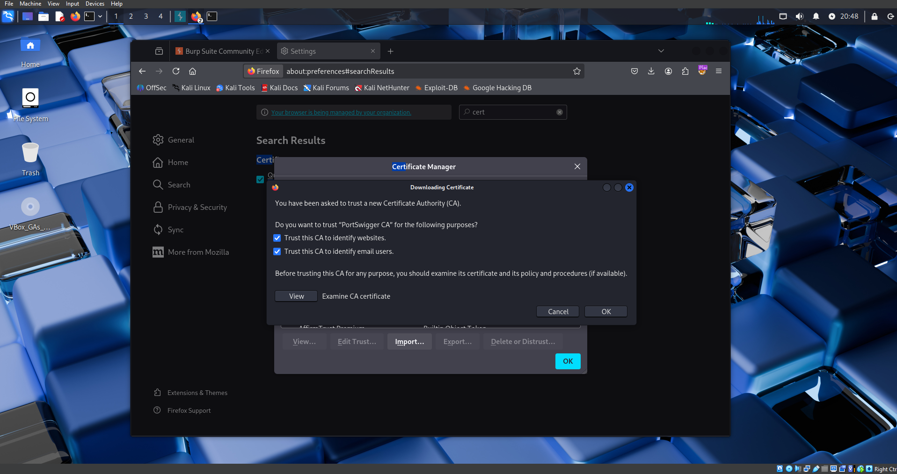  
Fig. 5 - A successful import of the Certificate in FireFox.****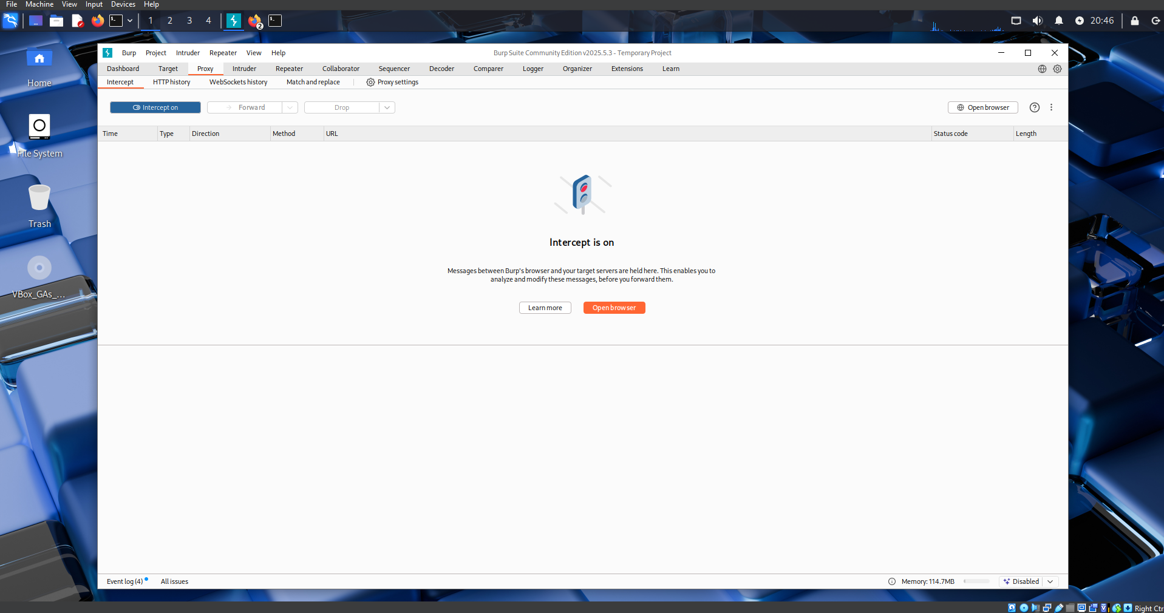****Fig. 6 - Intercept is turned on in BurpSuite  
  
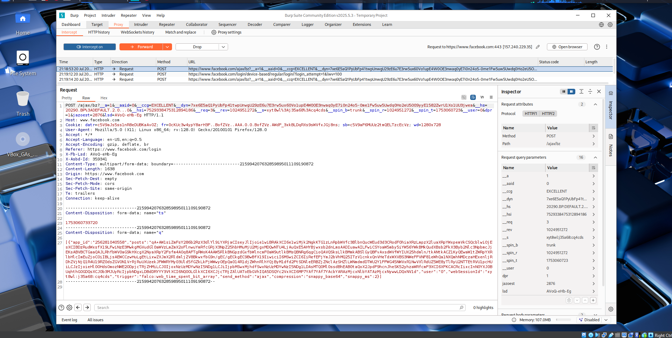  
Fig. 7 - Intercepted traffic after going to facebook.com/login and trying to log in.*